Learning Goal: I can retrieve information from a text.  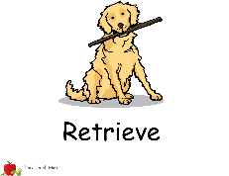  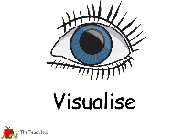  wait, magnificent, believe, whirl | 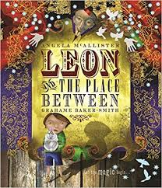  Independent Paired work  Group work Supported  Verbal Feedback
Fiction – Leon and the Place Between - Week 1
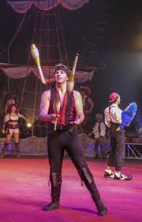
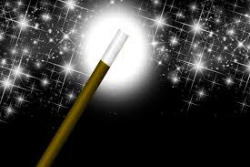
- Who did not believe in magic at the beginning of the story?
- Who did believe in magic?
- What did the jugglers wear?
- How did the jugglers throw their skittles up?

Extension choice 1 - Use the new vocabulary in sentences of your own.
Extension choice 2 – Draw the jugglers and label their clothes and skittles.
Silver Scaffolding
Learning Goal: I can retrieve information from a text.  wait, magnificent, believe, whirl | Independent Paired work  Group work Supported  Verbal Feedback
Fiction – Leon and the Place Between - Week 1
- Who did not believe in magic at the beginning of the story?

did not believe in magic at the beginning of the story.
- Who did believe in magic?

did believe in magic.
- What did the jugglers wear?

The jugglers wore
- How did the jugglers throw their skittles up?
The jugglers threw their skittles up
Extension choice 1 - Use the new vocabulary in sentences of your own.
Extension choice 2 – Draw the jugglers and label their clothes and skittles.
Bronze Scaffolding
Learning Goal: I can retrieve information from a text.  wait, magnificent, believe, whirl | Independent Paired work  Group work Supported  Verbal Feedback
Fiction – Leon and the Place Between - Week 1
- Who did not believe in magic at the beginning of the story?

Leon | Tom | Pete |  | Little Mo
- Who did believe in magic?

Leon | Tom | Pete |  | Little Mo
- What did the jugglers wear?

black suits | grey suits | colourful suits |  | sparkly suits
- How did the jugglers throw their skittles up?
with great care | with great speed
Extension choice 1 - Use the new vocabulary in sentences of your own.
Extension choice 2 – Draw the jugglers and label their clothes and skittles.

