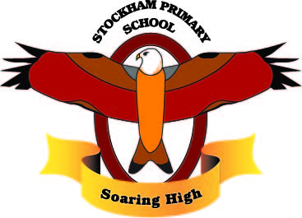
Topic/Subject: Incredible Me!

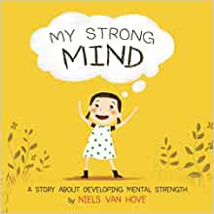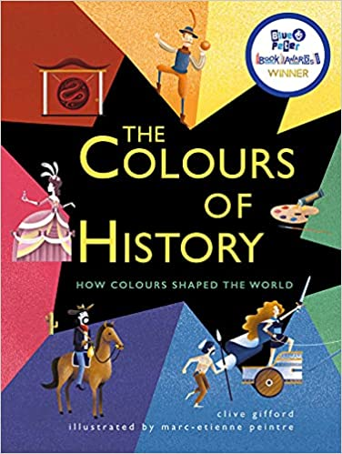
Breadth:

As Writers: Instructions and Poetry  - Use titles, headings and sub-headings.  - Use a range of grammatical devices; similes, adjectives, time adverbials, rhetorical questions, noun phrases, onomatopoeia, alliteration, imperative verbs.  - Use bullet points and brackets.  - Use complex sentences that include ‘if,’ ‘when’ and technical vocabulary.  - Extend our sentences using appropriate conjunctions.  - Order and sequence paragraphs.  - Use metaphors and rhyme.  - Use our senses to describe.  - Plan, write, edit and improve.  Texts:  Class reader:  Fiction: My Strong Mind  Non-Fiction: The colours of History  Outcomes:  Write instructions about how to have a strong mind.  Write a poem using my senses. |  | As Athletes: Ball Skills Invasion Focus.  - Dribble a ball using both feet.  - Indicate to a partner where you want to receive the ball.  - Throw and catch overarm and underarm.  - Kick a ball to a moving partner.  - Pass and receive effectively.  - What are the rules of a game?  - What can you change to make the game more difficult?  - What is our favourite team game and why? | As Artists: L S Lowrie  - Who is LS Lowrie?  - Matchstick Men  - Tints, tones and shades  - Perspective  - Paint like Lowrie | As scientists: Animals including humans.  - Identify that animals including humans need the right types and amounts of nutrition.  - Construct and interpret a variety of food chains, identifying producers, predators and prey.  - Identify that humans and some animals have skeletons and muscles for support, protection and movement.  - Pose questions that can be investigated.  - Gather data systematically.  - Present and evaluate the results from an investigation.
As readers:  - Read and listen to a wide range of styles of text.  - Listen to and discuss a wide range of texts.  - Use texts to infer, predict, explain, retrieve, summarise.  - Ask questions to improve understanding of a text.  - Retrieve and record information from non-fiction, using titles, headings, sub-headings and indexes. |  | As Mathematicians:  - Interpret and present data using bar charts, pictograms and tables.  - Solve one-step and two-step questions using information in scaled bar charts, pictograms and tables.  - Measurement length- explore equivalent lengths, converting lengths, adding lengths and perimeter.  - Fractions- halves, thirds, quarter, equivalence. | As linguists (French):  - Give and respond to simple instructions.  - Use vocabulary to describe parts of the body.  - Ask and answer questions about my body.  - Read and write simple words.  - Use a French Dictionary to develop my vocabulary further. | As musicians: Three Little Birds  - Explore reggae music.  - Listen and appraise a piece of music.  - Understand pulse and rhythm.  - To sing in unison.  - Improvise using instruments.
As computer Experts:  - Develop sequential algorithms.  - Begin to use the de-bugging process.  - Use loops to more easily communicate instructions.  - Draw images by using simple loop instructions. |  | As Geographers: My European Neighbours.  - Ask and answer geographical questions about the physical and human characteristics of a location.  - Explain my own views about a location.  - Name and locate the countries of Europe and identify their main physical and human characteristics.  - Describe geographical similarities and differences between countries. | Religious Education: What do Sikhs believe?  - The 5 K’s  - Sikhism and equality  - Why do Sikhs meditate?  - Working hard and living honestly.  - Let’s share. | As citizens (PSHCE):  - Set myself a fitness challenge.  - I know what it feels like to make healthy choices.  - Identify how I feel about drugs.  - Express how being anxious or scared feels.  - Take responsibility for keeping myself and other safe.  - Respect my body and appreciate what it does for me.
Key Vocabulary: | Commitment, control, challenge, confidence, endoskeleton, homo-sapiens, mammal, tendon, vertebrates, continent, landmass, region, population, enclave, inhabitants, international, tourism, cultural, historical, interdependence, physical feature, human feature, diversity, nutrition, dairy, starch, sugars, carbohydrates, balanced diet, food group, herbivore, carnivore, omnivore, vertebrates, invertebrates, muscles, producers, predators, prey.

Curriculum Drivers: | Curiosity: | Knowledge of the wider world: | Aspirations:
 | - What is Europe and where is it in the world?  - What countries is England ‘neighbours’ with?  - How can I travel to other countries?  - What does it mean to have a ‘Strong Mind’? | - What the location of the UK in terms of other areas of Europe?  - How does my life compare to living in other areas of Europe?  - How does London the capital city of England compare to Paris the capital city of France? | - What other countries I would like to visit?  - What careers would I be able to undertake in another European country?  - Understand the important influence of having a ‘Strong Mind’.

Home learning: | Year 3 homework for this term will be the following:  - Weekly logging into Spelling Shed to practise the weekly spellings – 5 games to unlock other games  - Weekly logging into Times Tables Rockstars – 15 minutes to release other games.  - Reading- recorded into the reading diary to be entered into the readers raffle every Tuesday and Key Stage 2 readers raffle at the end of term.  - One item to be chosen from the homework menu per week, to be handed in on the last Tuesday of term i.e. 6 pieces chosen from the menu to be handed in on Tuesday 5th April.

