Mathematics
Money

Place Value Revision

Addition/Subtraction Revision
English
A range of stories by a significant author ANTHONY BROWNE (Animal Characters)

Poetry
RUMBLE IN THE JUNGLE BOOK

Phonics, Guided Reading & Comprehension Tasks
Things your child will need this term please
- A clearly named art apron (this could simply be a large old shirt)
- Sun hats everyday (please name these clearly)
- A full outdoor PE kit with trainers

Religious Education
Christianity – God and the Church

Islam – God (Allah) and His Messenger
Physical Education:
Movement
(running/jumping/throwing/catching)

Competition against yourself and others

Summer Games with kicking and catching skills

PSHCE:
Changes

Rumble in the Jungle!
Year 2 Term 6
Mrs K Mascord
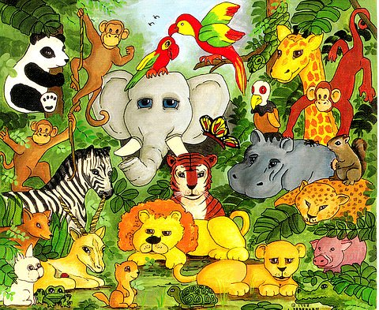
Computing
Productivity
WE ARE ZOOLOGISTS
Art & Design/Design & Technology
Drawing and Painting

JUNGLE PAINTINGS – HENRI ROUSSEAU

Dates to Remember!
Friday 8th June Talent Competition Entries to be submitted by today.
WB 11th June Phonics Tests for some Year 2 Children.
Wednesday 4th July Class Trip to Marwell Zoo!
Thursday 5th July Class Swap Afternoon to meet new Class Teachers
Wednesday 11th July KS1 Sports Day at 9.30am.
Friday 13th July School Summer Disco.
Monday 16th July Annual Reports Home to parents.
Wednesday 25th July End of Term at 12.10pm.

Science
Living Things and their Habitats

Music

Songs about jungles and animals
MOWGLI IN THE JUNGLE
ANIMAL AWAKENING

Geography
Continents, maps, atlases and globes
LIFE IN THE JUNGLE

