English  - Write legibly using appropriate joins.  - In narrative, create settings, characters and plot.  - Plan, draft, edit, improve and proof-read our writing.  - Use paragraphs to organise our work.  - Use nouns, pronouns, conjunctions, adverbs, fronted adverbials, prepositions, possessive apostrophes and direct speech.  - Spell homophones and commonly misspelt words correctly.  - Read our work aloud.  - Listen to and discuss a wide range of fiction, poetry, plays, non-fiction and reference books or textbooks.  - Read and understand root words, prefixes, suffixes and exception words.  - Use dictionaries to check the spelling and meaning of words. | 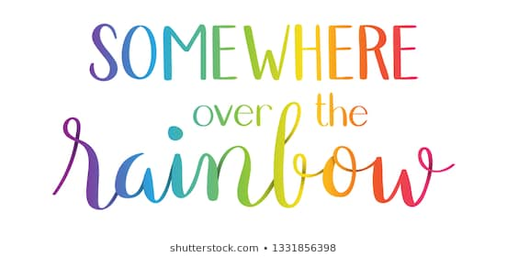  Year 3  Term 3 | Maths  - Recall and use multiplication and division facts for the 3, 4 and 8 multiplication table.  - Write and calculate mathematical statements for multiplication and division using the multiplication tables that they know, including for two-digit numbers times one-digit numbers, using mental and progressing to formal written methods.  - Interpret and present data using bar charts, pictograms and tables
PE: Gym & Swimming
- Develop flexibility, strength, technique, control and balance
- Swim competently, confidently and proficiently, using a range of strokes
French
- Join in, speak, listen and respond
- Colours
Music  - Listen with attention to detail and recall sounds with increasing aural memory  - Appreciate and understand a wide range of high-quality live and recorded music drawn from different traditions and from great composers and musicians | Art: Landscapes and Cityscapes  - Learn about great artists, architects and designers in history.  - Improve our mastery of art and design techniques, with a range of materials. | Geography  - Understand geographical similarities and differences through the study of human and physical geography of a region of the United Kingdom and a region in a European country
PSHCE  - Knowing when something is my fault and when something is not my fault  - Take responsibility for my behaviour  - Recognise things that hurt my feelings  - Know when I feel guilty and use this when making choices  - Know what to do if I feel guilty or ashamed  - Understand how I might hurt others  - Know how most people feel when they lose something or someone they love. | Science: Light  - Recognise that we need light in order to see things and that dark is the absence of light  - Notice that light is reflected from surfaces  - Recognise that light from the sun can be dangerous and that there are ways to protect our eyes  - Recognise that shadows are formed when the light from a light source is blocked by an opaque object  - Find patterns in the way that the size of shadows change | RE  - Learn about key features of two churches and the similarities between them.  - Ask important questions about the nature and purpose of the churches.  - Consider and reflect upon what they have seen in the two buildings.  - Learn about the impact of key features of the church building on those who worship there.

Homework
Homework will continue to be sent home each week on a Wednesday.
Please could homework be handed in on the following Monday.

Reading
Children are also expected to be reading at home at least 3 times a week;
please sign their Reading Journal to confirm this. Thank you!

Equipment and PE kit
As ever, your child will also need their book bag (with Reading Journal),
water bottle, plimsolls and PE kit (including trainers) in school every day.
Please remember they will also need their swimming kits on Tuesdays.
(all items clearly named, please!)

Dates for Your Diaries
Wednesday 5th February 2:40pm Year 3 assembly to parents
Friday 7th February Valentine’s Disco (details to follow)

Thank you for your continued support, please do not hesitate to contact me
if there is any further information you require.

