**Science: States of Matter**

* Describe the properties of solids, liquids and gases
* Explain what happens to states of matter when the temperature changes
* Explain the process of condensation and evaporation.
* Describe and understand the water cycle.

**Maths**

* **Number- place value**
* Romans numerals
* Rounding to the nearest 10, 100 and 1000
* Counting in 1000s and 25s
* Partitioning
* 100 more or less
* Comparing numbers
* Negative numbers
* **Addition and subtraction**
* Adding and subtracting 1s, 10s, 100s and 1000s
* Adding and subtracting two 4-digit numbers – no exchange and exchange
* Efficient subtraction
* Estimating and checking

**English**

**Fiction –**

Traditional tales – Writing to entertain “How the Frog Came to be the King of the Rivers and Marshes.

**Non-fiction-**

Writing to inform – explanation texts

**SPAG** (Spelling, Punctuation and Grammar) – pronouns and apostrophes. Year 3/4 word list.

Weekly spelling patterns.

**ICT**

* We are software developers – developing a simple educational game.

**Geography**

* Locate key rivers in the U.K and other countries.
* Explain how a river is formed.
* Describe the different parts of a river.
* Describe different ways in which rivers are used.
* Identify and describe the different features of a river.
* Explore flooding and the use of dams

**Trip to Letcombe Brook**

**Homework**

**Set every Wednesday to be handed in / completed by the following Tuesday morning,**

* Spellings are set weekly, given based on the Year 3/4 list or spelling pattern. –look out for new SpellingShed information coming soon.
* Maths is set every Wednesday based on what we have been working on that week. This may be via the Mathletics login.
* An additional topic homework will be set. This may be written or practical.
* Children should also spend 20 minutes reading, 3 days a week. **Reading diaries will be checked on a Tuesday and should be in school every day.**

Ter m 1 - Rivers and

the Water Cycle

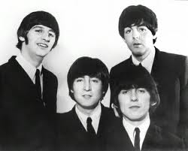

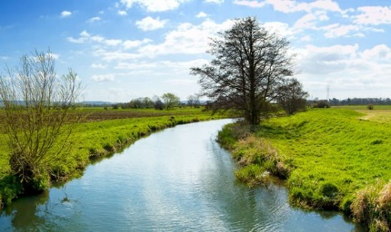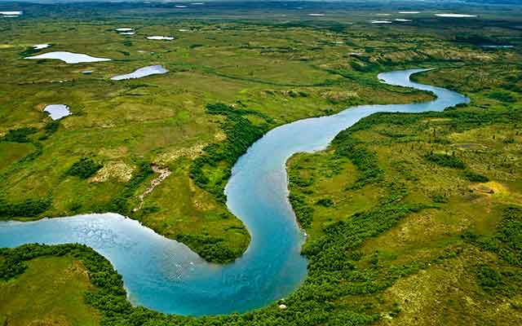

**RE: What is my view of the Bible?**

* Why is the Bible a special book for Christians?
* How is the Bible divided?
* How do Christians use the Bible?
* How does the Bible influence a Christian’s life?

**PE**

* Invasion games - Hockey
* Gymnastics - Balance

**Music**

* Recorders and Sing-Up songs.

**French**

* Greetings

**PSHE & SEAL: New Beginnings**

* Devise class rules
* Understand Stockham’s ‘Learning Powers’.
* Recognise your gifts and talents and those of others.