Topic/Subject: Local Area Study – Wantage

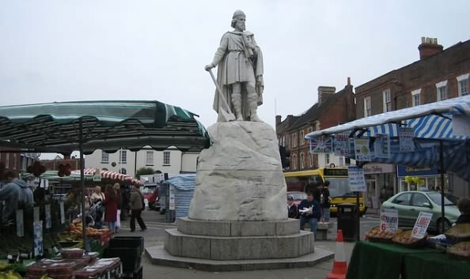
Breadth:

As writers: Narrative  Sentence Structure, Alliteration, dialogue, symbolism  Texts:  Class reader: The Nowhere Emporioum  Non fiction: Magic – Houdini  Narrative: The Nowhere Emporium |  | Being physically active:  Create complex and well-executed sequences that include a full range of movements.  Hold shapes that are strong, fluent and expressive.  • Include in a sequence set pieces, choosing the most appropriate linking elements.  • Vary speed, direction, level and body rotation during floor performances.  • Practise and refine the gymnastic techniques used in performances. | As Artists:  - Explain some of David Hockney’s work and describe the colours/mediums he uses to produce his work.  - Creating a spectrum of colours using paint, and building up texture using brush strokes and tools for mark making.  - Draw and paint a piece of work in the style of David Hockney’s landscapes, citing where he has inspired their work.  - Critique their own work and suggest areas for future development | As scientists:  - Identify different forces  - Explain the force of gravity  - Investigate the effects of air resistance, water resistance and friction  - Explore mechanisms
As readers:  - Recommending books  - Exploring the meaning of words  - Making comparisons  - Inferring  - Summarising |  | As Mathematicians:  - Multiplication  - Statistics  - Fractions | As linguists (French):  - Name places in a town  - Give directions  - Ask for directions to certain places | As musicians: How does music improve our world?  Listening to, appreciating, understanding and performing music – Freedom is Coming, All over Again.
As computer Experts:  - Use variables, ‘if statements’ and time in a code programme.  - Programme a button to move an object around, change an objects speed and direction and use a loop in a code. |  | As Geographers:  - Investigate places, patterns and communicate geographically.  - Use maps, atlases, globes and digital computing to locate countries and describe their features.  - Use 8 points of a compass.  - Identify 4 figure and 6 figure grid references.  - Use symbols and keys to build knowledge of the UK  - Use fieldwork to observe measure and record the human and physical features in the local area using a range of methods (sketch maps, graphs and digital technologies).  - Understand geographical similarities and differences through the study of human and physical geography in an area of the UK. | Religious Education:  - Understand some key facts of Judaism.  - Understand how the commandments express a relationship with God.  - Recognise the features of a synagogue.  - To be able to describe the story of Easter and make links to religious beliefs  - Investigate the meaning of Purim. | As citizens (PSHCE):  - Describe some of my dreams and goals  - Compare my hopes and dreams with those of young people from different cultures  - Explain why the dreams and goals of young people from different cultures might be different from my own and give reasons for this.
Key Vocabulary: | Capital city, residential, industrial, commercial, recreational, terraced, semi-detached, detached, flats, bungalow, Land use, Market, rural, service industry, settlement pattern, shopping centre, site, situation, suburb, urban, urbanisation, eastings, northings, grid reference, six figure and four figure grid reference  Force, gravity, friction, air/water resistance, mechanism, gears, levers, pulleys, mass, weight, variable.

Curriculum Drivers: | Curiosity:  - To understand that maps have a grid system that you can use to locate places with accuracy.  - To understand there are different types of buildings and what they are used for.  - To know understand that land is used for different purposes.  - To know who lives in Wantage and what they do. | Knowledge of the wider world:  - To know how Wantage is similar and different to other localities that are studied.  - Understanding how the Wantage is interconnected to the rest of the UK and world.  - Understand how my life is both similar and difference to others. | Aspirations:  - Knowledge of different careers in the local area including STEM  - Knowledge of different housing types.  - Knowledge of how changes to the local area have had a positive effect.

Home learning: | Year 5 homework for this term will be the following:  - Weekly logging into Spelling Shed to practise the weekly spellings – 6 games to unlock other games – the spellings can be practiced in their homework books too.  - Weekly logging into Times Tables Rockstars – 15 minutes to release other games.  - Reading- recorded into the reading diary to be entered into the readers raffle every Thursday and Key Stage 2 readers raffle at the end of term.  - One item to be chosen from the homework menu per week, to be handed in every Thursday

