STOCKHAM PRIMARY SCHOOL
THURSDAY NEWSLETTER

Issue No: 441 Thursday 18th May 2017
Dear Parents,
The staff and governors had an excellent, informative vision meeting on Tuesday evening at the school. We discussed the strengths of the school and celebrated many positive areas which we are proud of. Some of these areas included: fantastic parent support, the excellent progress that the children make in all subjects by the time they leave the school, forest school, after school clubs, visitors, special assemblies and our rich and varied curriculum. We looked at our learning powers and growth mind set; this will be a focus for the school to share with you as parents in the near future.
We also put together a list of short term and long term goals in order to develop the school further. If you have any suggestions, please note them down and bring them into school. I will leave a gold box in the front entrance.
Reminder –Please collect your loose change/coins. The FOS will be measuring each classes treasure on the 26th May. The class with the most treasure wins a prize. As part of the new playground improvements we would love to buy a new sandpit and toys for the KS1 playground.
Interviews will be taking place on Monday for our new full time teacher. Year 3 will be working with our 4 applicants and helping the interview panel.
Hot chocolate with the (Assistant) Head! – Well done to Zoe Brooks, Ryan Ledbury, Lilly Nickerson, Lillie Palmer, Kaine Walton, Emma Sanderson and Mia Cranstone for being recognised this week. This will take place on Thursday break time this week with Mr Burbank.
Thank you,
Mrs Burbank.

PAs this week were Lily and Matylda. Thank you for your help.

Please have a rummage down the back of the sofa and a good clear out of your bag where all the dust and lost coins linger at the bottom! All next week, classes will be collecting loose change for our Change Challenge (any denomination of coins is fine - as long as it’s legal British tender)! On Friday 26th, Friends of Stockham will be measuring the treasure from each class, awarding a prize for the class who collects the highest volume of coins. It’s all for a good cause, the money raised will be put towards the playground upgrade project. Thanks for your support.

CLASS NEWS

Year F In maths we have been learning how to measure. We had great fun measuring our
favourite toys! We have learnt about animals around the world and we wrote about
how different animals move.
Year 1 In English this week we have been making our own pirate themed dictionary. We
have been making sure this is in alphabetical order! We have been using the Bee
Bots in our computing lessons to navigate a pirate treasure map.
Year 2 This week Year 2 have made everyone so proud as they have been showing off all
they have learnt! We have also completed our science unit on Animals (including
humans) by looking at healthy diets, exercise and keeping clean.

Year 3 This week we have made a maths tool kit to help us remember the different
strategies we can use to solve problems in maths. In English we have been
continuing to explore explanation texts.
Year 4 This week Year 4 completed their Roman chariot models and they look fantastic!
In English we have begun writing an advert for a Roman villa. In maths we have
been learning how to translate shapes on a coordinate grid. We have also begun
to learn 'Mama Mia' on our recorders.
Year 5 This week in Year 5, we have started learning about the Ancient Greeks in English,
this will be our topic next term too. In PE, we have been playing games of cricket!
Year 6 This week in Year 6, in English, we have been writing facts about the wonders in
North America. We have been playing ultimate frizbee and rounders in PE. In
geography we have been learning about the longitude and latitude lines on a map.
In science we have been classifying animals into groups.

Soaring High
This week the following children have earned “Soaring High”:
Year F Peter and Frankie for persevering and not giving up on their writing about
animals.
Year 1 Harry for working independently and methodically in maths and design this week.
Milly for showing an excellent understanding of split diagraphs in phonics and
using them to read and spell. Well done you two!
Year 2 All of Year 2 for doing so well in their assessments this week!
Year 3 Harley for great perseverance with his handwriting. Lucy G for working really well
in a team to solve maths problems.
Year 4 Ava for always challenging herself by going 'deep sea diving'!
Riven for a more positive attitude towards all his work.
Year 5 Angel L for being a great back stop in cricket; she really thought about how
important team work is. Leo for working independently to produce great work in
English.
Year 6 Zachary and Freya for being really determined in geography, and producing
‘deeper thinking’ map explanations.

Well done everyone!

Tidy Tiger
This week Tidy Tiger goes to Year 6 for having the tidiest room. Well done!

Attendance Ted
Attendance Ted was awarded to Year 6 for having the best attendance last week, they will be looking after Attendance Ted next week. Well done Year 6!

School Uniform
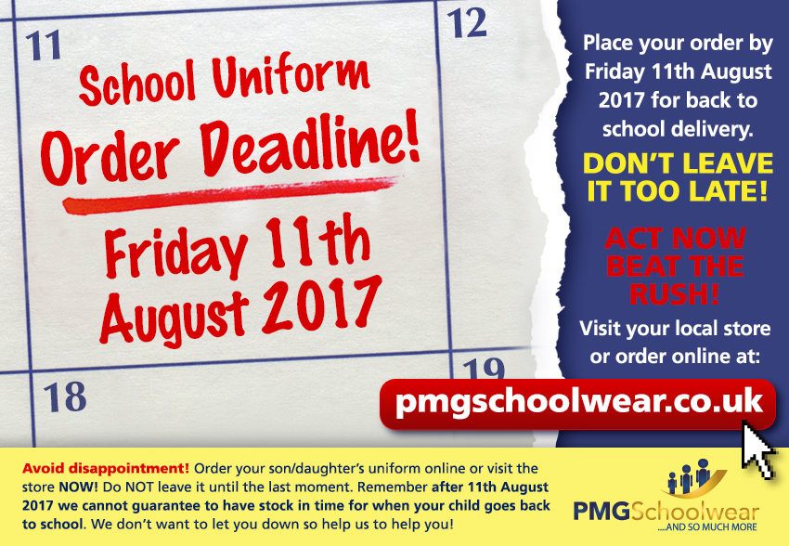
If you need new uniform please order online or by telephone. The website is pmgschoolwear.co.uk and the order line is 0800 4046644.
Book bags and PE bags are also available to be purchased from pmgschoolwear.

