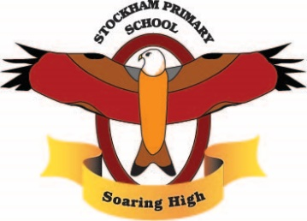

Curriculum Long Term Overview 2022-23
 | Autumn Term | Spring Term | Summer Term
Whole School Theme |  | The Lost Words (Poetry)
Values  Cycle 2 | Curiosity  Respect | Hope  Honesty | Love  Resilience
Learning skills | -Independence – Confidence – Listening – Teamwork  - Perseverance
Curriculum drivers | Aspirations – Who could I be? How can I aim high? How can I make the most of my opportunities? What opportunities are out there for me?  Curiosity – What do I think? What do I wonder? Why?  Knowledge of the world – Who am I? What is my locality? How does my life compare to the wider world? How do I fit in to the wider world? How can I take responsibility for both my community and the wider world?
EYFS | Getting to know you  Light and dark | Toys and superheroes  Growing | Pirates  Once upon a time  Under the sea
Year 1 | Marvellous me  Cloudy with a chance of rain | A journey of a thousand miles.  Memory Box | Stone walls and turrets  Spectacular skies
Year 2 | Hooray for heroes  A United Kingdom | Stormy skies  Spring is here | Rumble in the jungle  Beside the seaside
Year 3 | Tribal tales (stone ages)  An Oxfordshire road | Walk like an Egyptian  Tribal tales (iron and bronze age) | Adventure is out there  Rocks relics rumble
Year 4 | Rivers and Mountains  Romans | All about me  Europe | Inventions  Vikings/Anglo Saxons
Year 5 | South America  Greeks | World War 2  Biomes | Earthquakes and Volcanoes  Victorians
Year 6 | Frozen North  Mysterious Maya | No planet B/Climate change  Marvellous Medicine | Terrible Tudors  Wonderful Wantage
Special Whole School Events | Anti-bullying Week  Athlete Visit | World Book Day

‘Soaring High’

