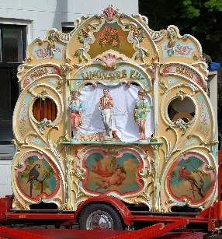

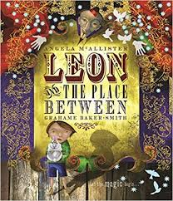 **Leon and the Place Between**

A barrel organ came from nowhere and the children were fascinated by its sound. The barrel organ monkey called an even stranger group of animals to the ring, that changed into new animals and objects before the children’s eyes. The mysterious music echoed around the tent.

The children’s minds were full of pictures and at last the music stopped. What would happen next? Leon knew it was time for the magic to happen. Suddenly, a magician revealed himself in a beam of light. He was dressed in a robe of gold, silver and sparkling jewels.

Sparks flickered and disappeared, and magic filled the marquee. Magical stars exploded from his fingertips.





** Leon and the Place Between**

A barrel organ came from nowhere and the children were fascinated by its sound. The barrel organ monkey called an even stranger group of animals to the ring, that changed into new animals and objects before the children’s eyes. The mysterious music echoed around the tent.

The children’s minds were full of pictures and at last the music stopped. What would happen next? Leon knew it was time for the magic to happen. Suddenly, a magician revealed himself in a beam of light. He was dressed in a robe of gold, silver and sparkling jewels.

Sparks flickered and disappeared, and magic filled the marquee. Magical stars exploded from his fingertips.