STOCKHAM PRIMARY SCHOOL
THURSDAY NEWSLETTER

Issue No: 437 Thursday 06th April 2017
Dear Parents,
What a wonderful last week to the Spring term. The week started with a visit from Jorja Douglas from CBBC’s TV show - ‘Got what it takes?’ We had an excellent assembly with both Jorja and the talented dance children sharing their talents. Thank you to all the parents and children who voted for Jorja to make it through to the final. She finds out on Friday but she has to keep it a secret until next Tuesday – fingers crossed.
Thank you to everyone who sent in a donation for non-school uniform day last Friday. We have raised £200.15 for the ‘Riding for the disabled group’ in Abingdon which will help towards the costs of their new arena. We look forward to sharing photos and videos of Sarah Ellis’ wing walk after the Easter holiday.
We are sadly saying goodbye to Miss Anne-Marie Bargery who has taught the Foundation class this year. She will be leaving this Wednesday in order to look after her health. We welcome Miss Rebecca Thomas (an experienced Early Years and KS1 teacher) who has already met the class and is very excited about teaching the class for the rest of the year.
Next term I am introducing ‘Hot chocolate Friday’. The idea of Hot Chocolate Friday is for the Head to invite a small group of chosen learners who have gone ‘over and above’ during the week to share a warm drink and a chat together. It’s an opportunity to spend time with members of the school who get on quietly but don’t always get the recognition they deserve. This is also an excuse for me to drink hot chocolate!
Evie Stoermer will be going for the chop on Monday 10th April and donating her hair to The Little Princess Trust who make wigs for girls undergoing treatment for cancer. She will be doing this as part of the fundraising her mum and dad are doing for a local charity called Team Mikayla. Mikayla was treated for brain cancer and she herself used a wig made through the Little Princess Trust. Mikayla went on to set up a charity called "Team Mikayla" who raise money to grant wishes for children with cancer. Any money Evie can raise from her hair cut will go to this charity together with the money raised by her mum and dad who are doing a "Tough Mudder" on May 7th. If you would like to make a donation please go to http://www.totalgiving.co.uk/mypage/tm17
Have a wonderful Easter break.
Thank you,
Mrs Burbank.

PAs this week were Joel and Lewis T. Thank you for your help.

 Thank you very much to Caroline and Rob Ellacott and Waitrose, for kindly arranging a very generous donation of compost and seeds for the school council healthy eating campaign.

Forest School
Last week at Forest School we made butter from cream and spread it on bagels toasted over the fire. (Toasting was a LOT easier than making the butter but it did taste good!) We also tried making popcorn but it burnt a bit :(
This week we made and ate Campfire Pizza after our Easter egg hunt, and learning about birds we might find in our local area. Some of us also made woodland sculpture animals to keep and remind us of our time at Forest School.

CLASS NEWS

Year F This week we have listened to the Easter Story and talked about new beginnings.
We’ve also made Easter cards.
Year 1 We have been ‘fixing’ sentences in English this week and in maths we have
been working on subtraction.
Year 2 This week we have finished our Great fire of London topic by creating a giant
piece of artwork. We will also be making bread on Thursday……and hopefully
not starting any fires!
Year 3 Year 3 have been consolidating their mental addition and subtraction strategies.
In English we have been designing our own crayon characters and writing letters
to Duncan from ‘The Day the Crayons Quit’.
Year 4 This week Year 4 have been learning about angles in maths. In English we have been finishing our reports on Romans. On Monday we made switches for electrical circuits in our science lesson.
Year 5 This week in Year 5, we have been writing instructions on how to trap a monster! In history we learnt all about the mystery of Sutton Hoo.
Year 6 This week in Year 6 we have been polishing our test papers. In literacy we have
started writing our news reports about Grace Darling.

Soaring High
This week the following children have earned “Soaring High”:
Year F Frankie and Skyla for fab Easter colouring.
Year 1 Alfie J for such hard work in all our lessons and for making so much progress in
maths. Alfie B for fantastic reading and writing this week. Well done!
Year 2 All of Year 2 for another fantastic term!
Year 3 All of Year 3 for a brilliant term!
Year 4 Lewis for achieving his reading target.
Jessica for showing confidence and being brave to try new things.
Year 5 Lauren for having the courage to sing on stage with Jorja and her sisters.
Ella for showing determination to understand how to find exactly half way
between two numbers!
Year 6 Cherry for excellent perseverance with her report writing and always working
hard in extra group sessions. Kulsuma for the amazing effort she puts into her
writing to always be the best she can be.

Well done everyone!

Tidy Tiger
This week Tidy Tiger goes to Foundation for having the tidiest room. Well done!

Attendance Ted
Attendance Ted was awarded to Year 5 for having the best attendance last week, they will be looking after Attendance Ted next week. Well done 5 Year!

On Tuesday 28th March, the Year 3 and 4 classes had their house boccia tournament! They all enjoyed the game and learnt some new skills. Congratulations to the green teams from both Year 3 and Year 4 for winning the tournament overall and earning a huge 20 points for their totaliser! Thank you to the adults for running the event and to Tilly and Logan from Year 6 for helping to lead it - you were excellent!

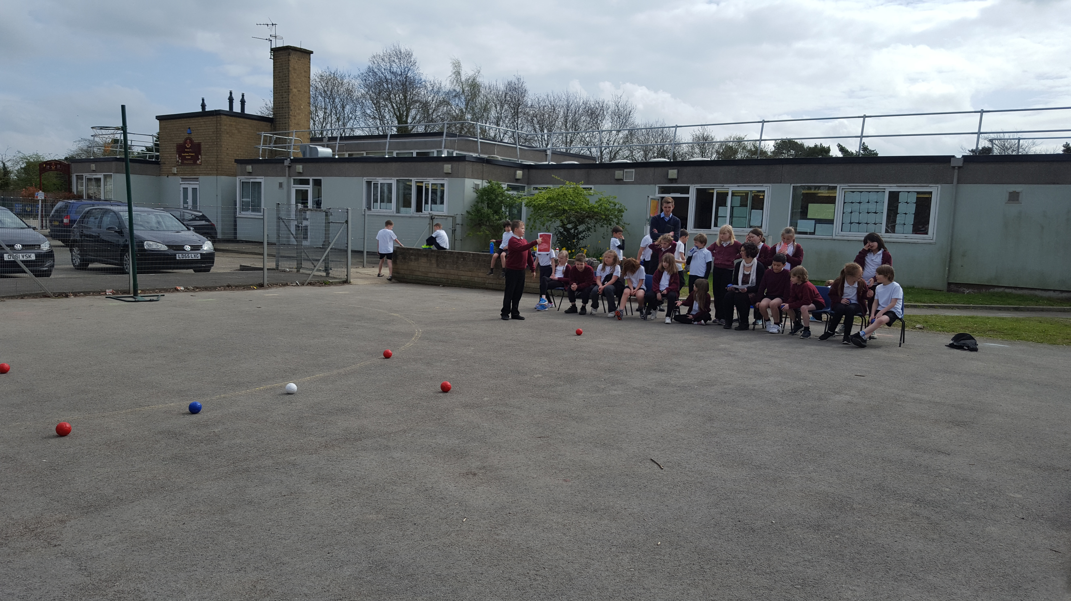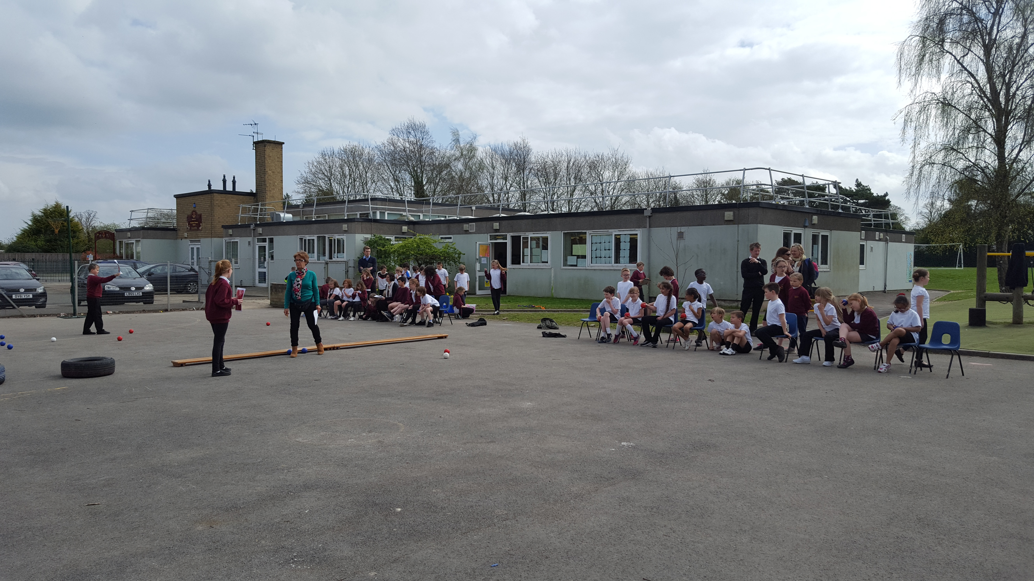

Trinity, Lawrence, Preston and their family held a cake sale to raise money for Cancer Research. They raised an amazing £204.53. Well done!

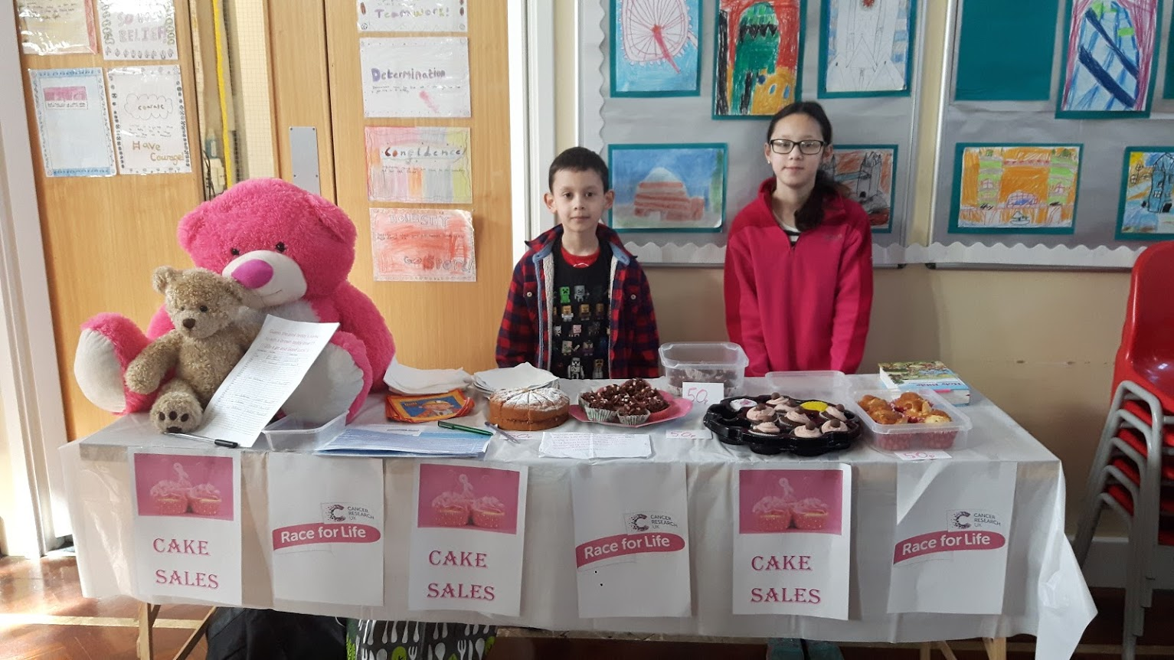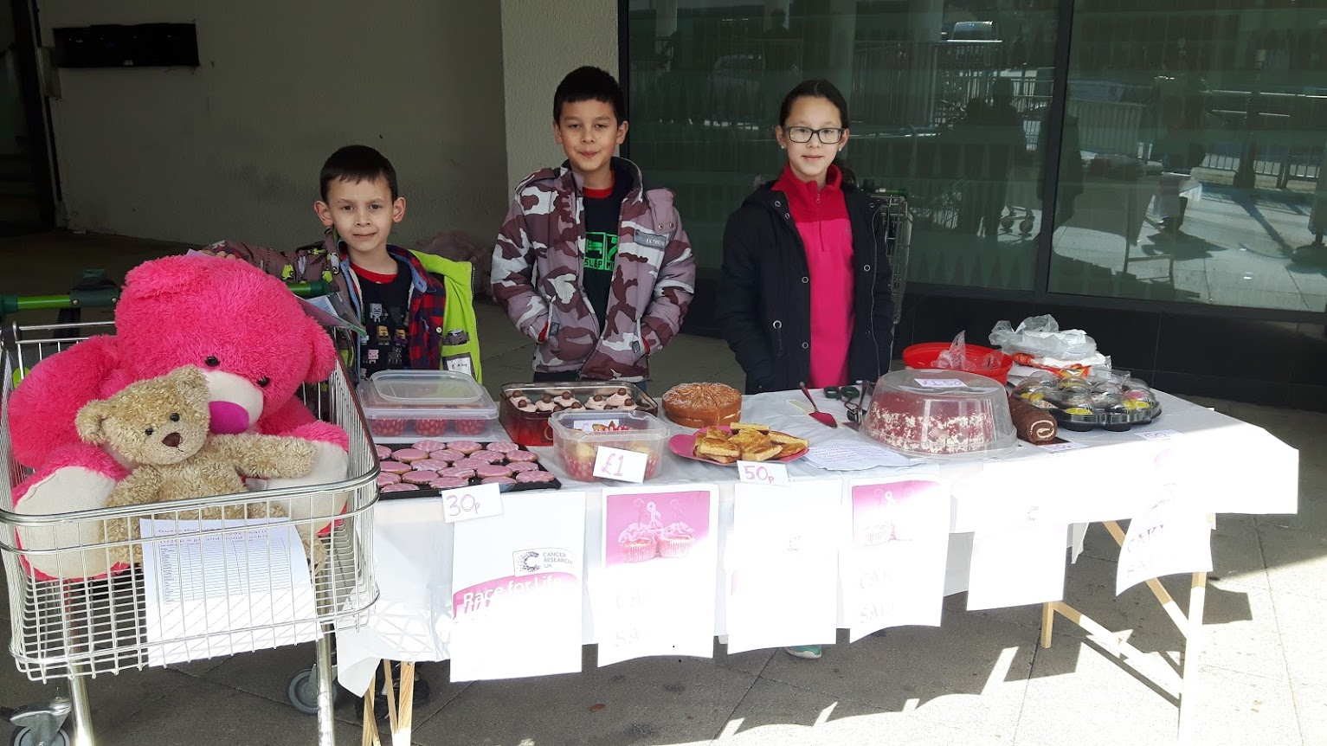

School Uniform
If you need new uniform please order online or by telephone. The website is pmgschoolwear.co.uk and the order line is 0800 4046644.
Book bags and PE bags are also available to be purchased from pmgschoolwear.

Message from Wantage Library
Ebooks drop-in support – Wednesday 17th May – 2pm – 4pm - Find out about our free ebooks, eAudio books and e-magazines using your smart device and library card! No need to book, just drop in!

