STOCKHAM PRIMARY SCHOOL
THURSDAY NEWSLETTER

Issue No: 440 Thursday 11th May 2017
Dear Parents,
We are very proud to announce that Stockham School has achieved the ‘Quality Mark Award’. We are only the second school in Oxfordshire to have achieved this. Well done to all the staff involved and thank you to Mrs Katie Roberts for leading the assessment day.
SATs - The Year 6 children were incredible this week. They worked so hard every morning and really tried their best. All the children were positive and never gave up. I hope that they enjoy their well-deserved BBQ and a relaxed rest of the week. Good luck to Year 2 who will start their showing off assessments next week.
We are having a visit from the Air Ambulance team on Monday 15th May. They will be talking to all the children about the work that they do and the equipment they use to help save lives locally. We are hoping that they might bring the air ambulance at a later date. Thank you to Alfie Gleed’s Dad for organising this event.
Katie Light (student from Oxford Brookes) will be gaining teaching experience in the Year 1 classroom for 5 weeks starting on Monday 15th May. Katie is a first year BAEd teaching student. Katie will be observing and teaching small groups.
Teddy Bears picnic – We will be having a teddy bears picnic on Thursday 18th May. Please can we ask that children bring in a favourite teddy and a picnic blanket? If the weather is nice, the children will eat outside on the field.
Hot chocolate with the Head! – Well done to Phoebe Partridge, Harry Wilson, Brooke Webb, Isla Gregory, Phoebe Way, Sophia Lloyd and Tilly Arnold for being recognised this week. I think Mrs Cargill found this week impossible to choose from Year 6; I may be having hot chocolate with all the year 6 children this week!
Thank you,
Mrs Burbank.

PAs this week were Amber and Jessica. Thank you for your help.

On Tuesday 25th April, eight children from Year 4 attended the tennis competition. They had some incredibly tough matches - even having to play against club players - and showed amazing determination and perseverance the whole time! Thank you to Tom from Wantage Lawn Tennis Club for working with the children in the run up to the day and supporting them at the event! Well done everyone!

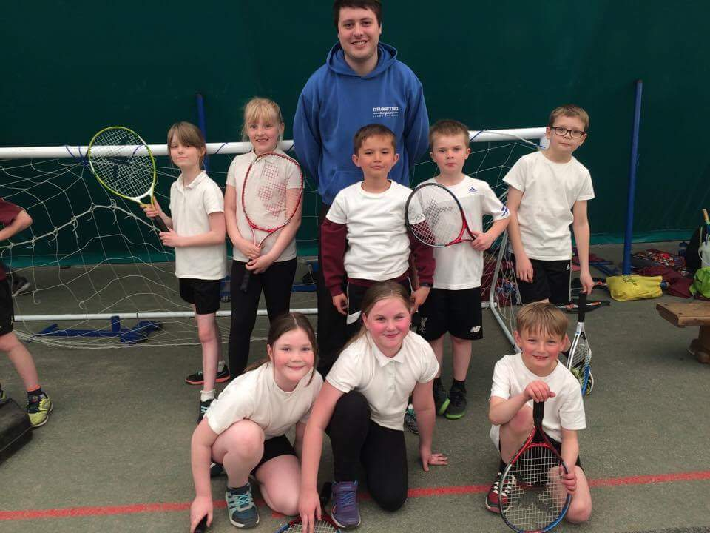

CLASS NEWS

Year F We are learning about road safety. We have made some ‘stay safe’ posters and
we have made road signs to use in our outdoor play area.
Year 1 In Year 1 we have been learning to multiply by 10 in our maths lessons. We
have been looking at dictionaries in English and have enjoyed playing some
alphabetical order games.
Year 2 In maths we have been revising multiplication and division, measuring and
symmetry. In science we have been learning about the basic needs of living
things, and have designed animal homes to provide these.
Year 3 Year 3 have been working hard looking at weights and measures in maths, and in
English they have been sentence stacking in preparation to write an explanation
text.
Year 4 This week Year 4 have been plotting coordinates in maths. We have begun
making Roman mosaics in our art and topic lessons. In science this week we
made a classification key to help us sort different minibeasts.
Year 5 This week, we have finished our reports about our Norse Monsters in English! In
science, we have been experimenting with different materials to see whether or
not they dissolve in water.
Year 6 This week Year 6 have been working hard doing their SAT’s. In art we have
been sketching. In PE we have been playing ultimate frizbee.

Soaring High
This week the following children have earned “Soaring High”:
Year F Nour for creating a fantastic road safety poster and Violet for writing a shopping
list (independently).
Year 1 Matthew for such a positive attitude towards his learning and for working
increasingly independently. Lily for always setting such a good example for the
class and for always working so hard.
Year 2 Ethan for great pride in his (much improved!) handwriting, and Luke for
perseverance with his reading and really impressing Mrs McNaught and Jenny.
Well done!
Year 3 Will and Isla for showing real pride when writing the first part of their explanation
text.
Year 4 Johnny for showing good teamwork and helping others with their work.
Izzy for completing her Reading Record every time she reads!
Year 5 Angel A and Maisie for brilliant editing and improving their reports in
English.

Year 6 All of Year 6 for being so confident and determined in their SATs this week. They
have all tried their very best!

Well done everyone!

Tidy Tiger
This week Tidy Tiger goes to Foundation for having the tidiest room. Well done!

Attendance Ted
Attendance Ted was awarded to Year 6 for having the best attendance last week, they will be looking after Attendance Ted next week. Well done Year 6!

Ukulele, Guitar & Drum Lessons
Ukulele and guitar lessons £6 per lesson and drums £7.50.
Please contact Lyn on 07761186304.

School Uniform
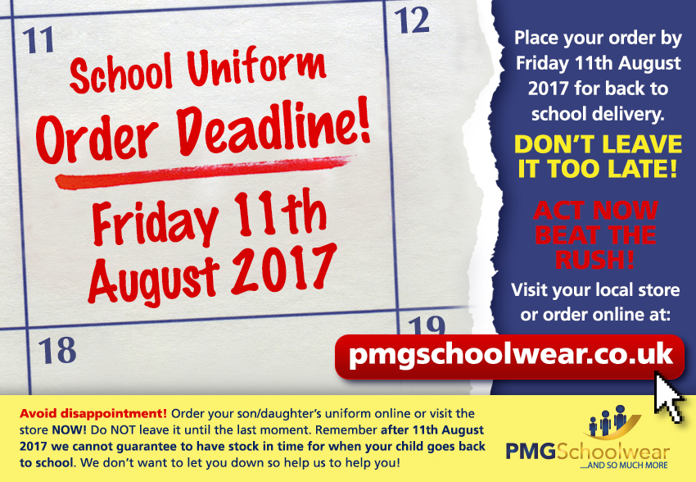
If you need new uniform please order online or by telephone. The website is pmgschoolwear.co.uk and the order line is 0800 4046644.
Book bags and PE bags are also available to be purchased from pmgschoolwear.

