STOCKHAM PRIMARY SCHOOL
THURSDAY NEWSLETTER

Issue No: 442 Thursday 25th May 2017
Dear Parents,
Over the half term we will be having work carried out on the KS1 playground. Work will commence on Thursday 1st June and will take approximately one week to finish. Please can I ask that at the start of next term all Foundation class, Year 1 and Year 2 children use the entrance to Camel pre-school to access the building during both morning drop off and at home-times.
This will be phase 1 – to include a wet pour surround and splash wet pour feature.
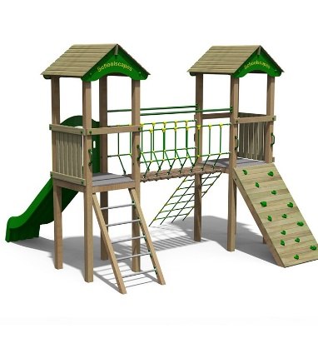
We are holding a coffee morning on the 16th June at 9am for any parents who are interested in joining us for a ‘Playful parents programme’. Please look out for a letter with more information about this program which will be sent home tomorrow.
Hot chocolate with the Head! – Well done to Shanley Rusher, Alfie Gleed, Hallie Payne, Evie Stoermer, Minah Abdallah, Finley Kerman and Matylda Zaprawa.
Reminder –Please collect your loose change/coins. Tomorrow morning the FOS will be measuring class treasure. Please help to fundraise towards our new KS1 playground improvements.
Next term begins on Monday 5th June. We will be welcoming a drumming group called ‘World Beats Music’ into assembly to share their drumming skills and inspire the children to take up drumming.
Thank you,
Mrs Burbank.

PAs this week were Tilly and Poppy. Thank you for your help.

On Thursday 18th May, 8 children from Years 5 and 6 attended the partnership cricket competition. They really impressed all the staff because, even with some tough games, they kept their heads held high, tried their best and couldn't wait to play their games. Well done to all of you for using your learning powers to represent our school so well!

On Thursday 18th May, Year 5 had their house cricket tournament. They all learnt new skills, showed determination to have a go if they were a bit nervous and had lots of fun. Congratulations to the green team who were the overall winners on the day!

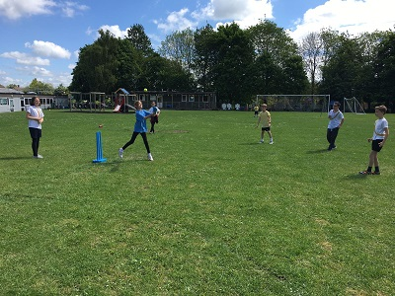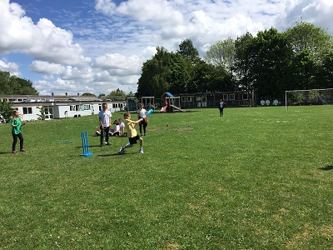

On Monday 22nd May, Year 6 had an ultimate frisbee competition. They had been practicing their skills in prior lessons and all put them to good use on the day. They were very determined to try their best and had lots of fun at the same time. Well done everyone, but a big congratulations to red house who were the champions on the day and earnt 10 points for their star totaliser!

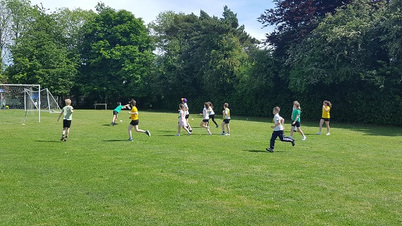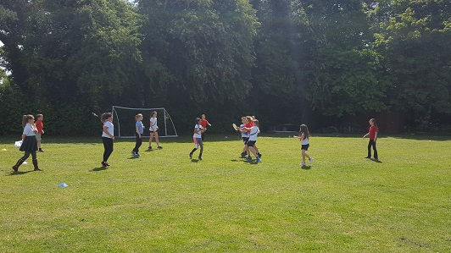

CLASS NEWS

Year F This week we are learning how to tell the time and we have been writing our own
smoothie recipes. We were very excited about making our smoothies too!
Year 1 We have been rehearsing lots and lots for our class assembly this week and we
enjoyed a very exciting Pirate Day on Monday. We particularly loved our treasure
hunt, walking the plank and our pirate feast!
Year 2 In English this week we have been writing riddles. In science we have investigated
whether children get faster as they get older.
Year 3 This week Year 3 have been measuring liquids in maths and designing robot dog
food in English. They have also been solving Mrs Kerman and Mr Burbank’s lack
of team work.
Year 4 This week Year 4 have been reading and interpreting data in tables and on bar
graphs in maths. In History we have designed posters to advertise Roman gladiator
battles! We enjoyed taking part in 'The Day the Teacher's Quit!' with the other
classes in Key Stage 2 on Wednesday.
Year 5 This week in maths we have been balancing equations! In science we used our
investigative skills to separate materials!

Year 6 This week Year 6 have been writing persuasive leaflets to encourage people to visit
North America. In art we have been painting with watercolours in the style of
Hundertwasser.

Soaring High
This week the following children have earned “Soaring High”:
Year F Jenson for writing a fantastic smoothie recipe and Owen for writing his name
independently.
Year 1 All of Year 1 for a wonderful class assembly. I am so proud of you all!
Year 2 Alfie Bayliss for coping so well while his arm was in a sling. Alex for great
determination when composing his riddle. Well done!
Year 3 Zak and Faith for always showing great team work in class.
Year 4 Cai for concentrating really hard on all his work.
Isobel for making a great classification key in science all on her own!
Year 5 Joseph and Finley for being brilliant learning partners. They used great team
work to help each other to success!
Year 6 Elliot K, Joe and Joel for all persevering and producing fantastic promotional
leaflets in English.

Well done everyone!

Tidy Tiger
This week Tidy Tiger goes to Year 5 for having the tidiest room. Well done!

Attendance Ted
Attendance Ted was awarded to Year 6 for having the best attendance last week, they will be looking after Attendance Ted next week. Well done Year 6!

Don’t forget to send in any (British legal tender) loose change that you can spare for the class coin collections. Collection jars will be measured and the winning class announced during assembly THIS FRIDAY.
Your child will bring home a bag for our clothing collection so you can have a sort out over the next few weeks. Clothing bags will be collected in school on Friday 23rd June (non-uniform day). Details of items we are collecting will be sent out with the bags before we break for half term on Friday.
We’re currently raising money for the playground upgrade project so everything and anything you can spare is appreciated. Thank you for your support. Friends of Stockham friendsofstockham@gmail.com

Wantage Library Events
Storytime and Craft – Saturday 17th June – 2pm - 3pm –Come and celebrate the start of the Wantage Summer Festival at our storytime and craft! Suitable for children aged between 3 to 8 yrs old! To book your free ticket, please phone Wantage Library on 01235 762291.

We also still have lots of tickets left for our Elmer Day Storytime and Craft on Friday 2nd June, 10.30am - 11.30am – why not pop into Wantage Library and book your free ticket!

School Uniform
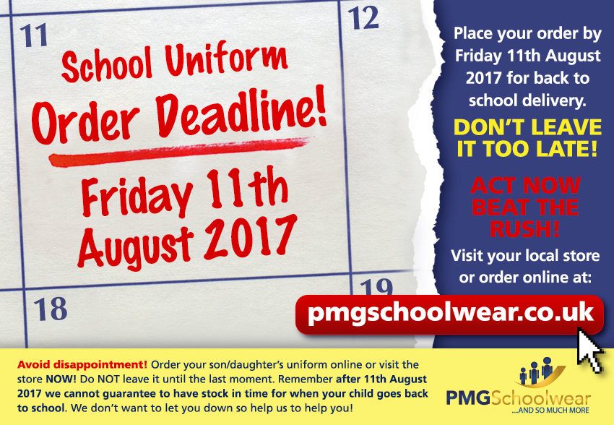
If you need new uniform please order online or by telephone. The website is pmgschoolwear.co.uk and the order line is 0800 4046644.
Book bags and PE bags are also available to be purchased from pmgschoolwear.

