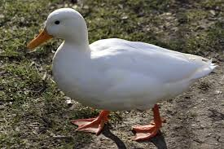
Farmer Duck Week 2
Farmer Duck got fed up with the farmer staying in bed all day. The farmer got fatter and fatter.
The duck sawed the wood.
The duck dug the garden.
The duck washed the dishes.
The duck washed the clothes.
The duck picked the apples.
The poor duck became very weepy and very sleepy, so he sat down and cried. The hens comforted him as they loved the duck. The wanted to help him and they came up with a cunning plan.

Farmer Duck Week 2
Farmer Duck got fed up with the farmer staying in bed all day. The farmer got fatter and fatter.
The duck sawed the wood.
The duck dug the garden.
The duck washed the dishes.
The duck washed the clothes.
The duck picked the apples.
The poor duck became very weepy and very sleepy, so he sat down and cried. The hens comforted him as they loved the duck. The wanted to help him and they came up with a cunning plan.

