Key Stage 2 Results 2018
 | % reaching expected standard or above |  | % reaching greater depth
 | Stockham School | National Average | Stockham School | National Average
Reading | 84% | 78% | 29% | 28%
Writing | 87% | 78% | 35% | 20%
Maths | 87% | 76% | 42% | 24%
R,W & M | 84% | 64% | 19% | 10%
Grammar & Spelling | 87% | 75% | 35% | 34%
Science | 90% | nya | n/a | n/a

3 Year Trend R, W & M
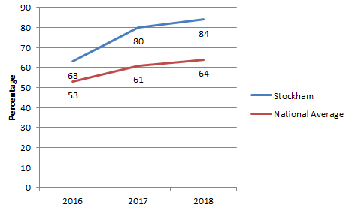
Scaled Scores
 | Stockham School | National Average | Difference
Reading Scaled Score | 107 | 105 | +2
Writing Scaled Score | 103.9 | nya | nya
Maths Scaled Score | 107 | 104 | +3
SPAG Scaled Score | 109 | 106 | +3

