STOCKHAM PRIMARY SCHOOL
THURSDAY NEWSLETTER

Issue No: 478 Thursday 24th May 2018
Dear Parents,
Year 2 have been working very hard to complete all their SATs assessments this week. All the staff are very proud of the children’s efforts.
Children from Years 4, 5 and 6 have had a wonderful time at the Lion King in London. It was an incredible show; enjoyed by all. Thank you Marie Martin for organising such a wonderful experience.
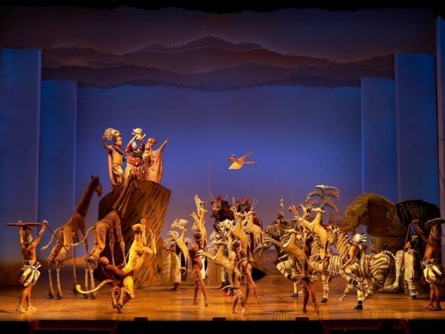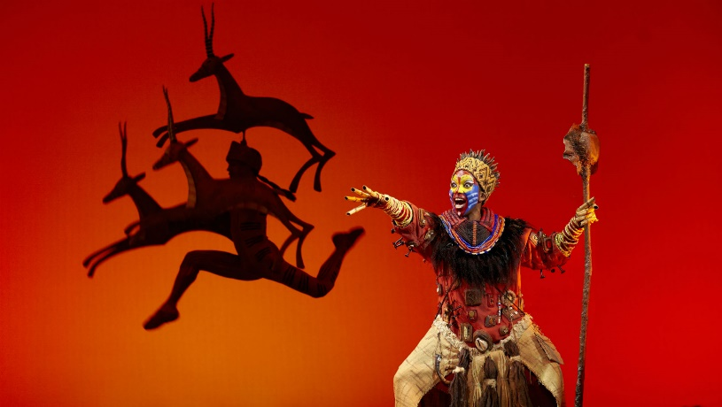

Class assemblies to parents:
Tuesday 12th June at 2.40pm – Year 4
Wednesday 13th June at 2.40pm – Year 5
Tuesday 19th June at 2.40pm – Year 1
Tuesday 3rd July at 2.40pm – Year 3
Wednesday 18th July at 2.40pm – Foundation
Wednesday 25th July in the morning (time to be arranged) - Year 6 leavers assembly

End of term – Friday 25th May 3.05pm.

Many thanks,
Mrs. Burbank

PA’s this week was Joshua W and Evan. Thank you for your help.

Mr. Burbank and Flo Stoermer are running 100km on 14th July along the ridgeway to raise money for Stockham School ICT equipment. If you would like to make a donation, please visit the link below to the Friends of Stockham Total Giving Page. Thank you!
https://www.totalgiving.co.uk/mypage/sssh

Messages from Friends of Stockham:
Thank you for sending in your coins, altogether you raised more than £170! Congratulations to Year 2 who collected the most.
This year, rather than contributing to an all school project, each class has requested a donation for individual needs. So far, Year 6 have had a visit from an archaeologist, Year 3 are purchasing a CD player and Foundation have put their funds towards their lovely new carpet space mat.
The clothing bags you donated back in January raised more than £200 and FOS have scheduled a further collection for Friday 8th June. Collection bags and full details will be sent home with your child soon but in the meantime, please save us your unwanted (re-usable) clothes, shoes, bags and bedding!
Also, in time for Father’s Day, FOS have organised a little treat for the children to give to someone special (£1 per gift). Full details will follow after the half term break.
Thank you for your support friendsofstockham@gmail.com

On Friday 18th May, Stockham hosted the Wantage schools rounders tournament. We entered 2 teams of Year 5/6 children into the event and they had a lot of fun in the sunny weather showing off their batting and fielding skills. Well done to one of our teams who came 4th in the event. It was also fantastic to see some new faces at the competition - well done to those children for being brave and trying something new!

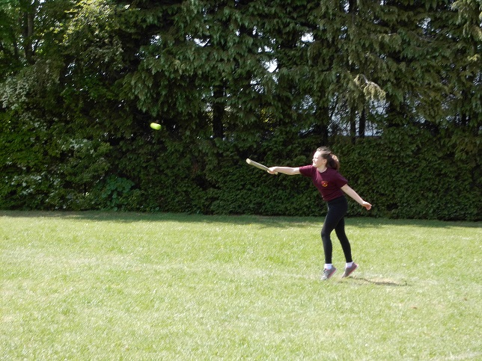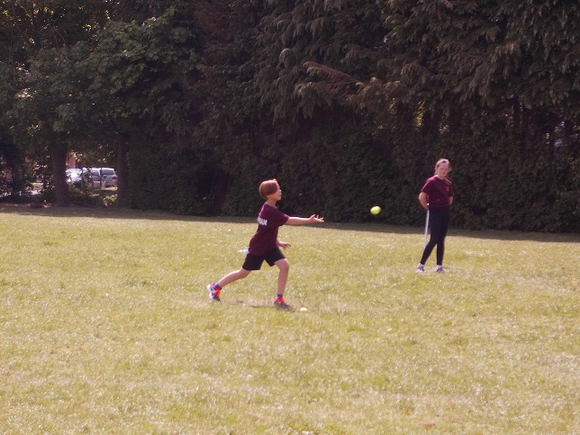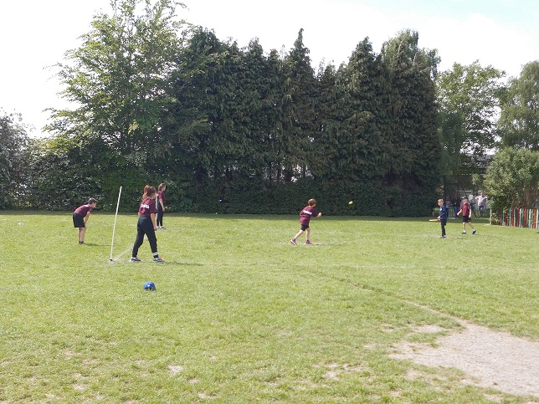

CLASS NEWS

Year F This week Foundation have been learning all about our tadpoles. We have made
our own posters showing the life cycle of a frog and labelled them. On Wednesday
the class loved using the play money to buy their own ice lollies! We have also been
learning about road safety, ready for our trip on Friday. The children were brilliant at
explaining how to stay safe out on the roads.
Year 1 In Year 1 this week we have finished writing our own fairy stories. We have also
compared our weather pictograms from terms 2 and 5, and we have completed our
2D model castles in DT.
Year 2 We have worked really hard on all our reading and maths assessments this week and
have enjoyed lots of topic time in the afternoons. We are particularly proud of our
moving vehicles that we have produced in D and T.
Year 3 This week in Year 3 we have been investigating and comparing our heights! We
had to find the best way to measure and the best unit of measurement. In English
we have been writing an adventure story based on our ‘Message in a bottle’ work.
Year 4 This week Year 4 took part in a house tournament in athletics, they all tried really
hard and had great fun competing in different events. In maths we have been
working on telling the time using a 24 hour clock. In history this week we learned all
about Boudicca and made some Wanted posters for her!
Year 5 We have been working really hard solving fraction problems in maths. In English
we have started writing poetry about our Pandora creatures.
Year 6 This week Year 6 have been working hard on their writing. In the afternoons we
have been playing rounders and cricket.

Soaring High
This week the following children have earned “Soaring High”:
Year F Lucy for her amazing writing. This week Lucy has been showing off her amazing
writing skills, writing all about the frogs and road safety! Max B for his brilliant life
cycle. Max drew an amazing life cycle of a frog, labelling each part.
Year 1 Amelia and Phoebe for showing fantastic listening and perseverance when
making their model castles. You listened to the instructions, coloured and cut your
castles carefully and added working sliding mechanisms to ensure your
portcullises opened and closed!
Year 2 All of Year 2 for working so hard on your assessments. I am so, so proud of you
all and very impressed with the Learning Powers you have used to do your very
best. Well done!
Year 3 Georgia for trying her hardest in story writing. She has impressed us with her
incredible attitude. George for a wonderful attitude to learning in general, he
always wants to find out more.
Year 4 Rosalind for settling well into Year 4. Owen for some great throwing skills in
athletics.
Year 5 Jaydon for being very confident with his writing – well done! Rory for using great
team work during our cricket competition.
Year 6 Lily and Casey for trying really hard on their descriptive writing and creating some
lovely pieces.

Well done everyone!

Tidy Tiger
This week Tidy Tiger goes to Year 4 for having the tidiest room. Well done!

Attendance Ted
Attendance Ted was awarded to Year 1 for having the best attendance last week, they will be looking after Attendance Ted next week. Well done Year 1!

School Uniform
If you need new uniform please order online or by telephone. The website is pmgschoolwear.co.uk and the order line is 0800 4046644.
Book bags and PE bags are also available to be purchased from pmgschoolwear.

