STOCKHAM PRIMARY SCHOOL
THURSDAY NEWSLETTER

Issue No: 472 Thursday 29th March 2018
Dear Parents,
Wow! Thank you so much to all the families who supported our school environment day. We were over-whelmed with donations. The staff and children are feeling very supported and want to thank you for coming in and giving up your time and muscles into improving various areas around the outside of the school. Thank you to Brian Jones from Wantage Gardeners Association for donating a wide range of resources and helping all morning. If you took any photos on the day, please send them to the office at office.2583@stockham.oxon.sch.uk
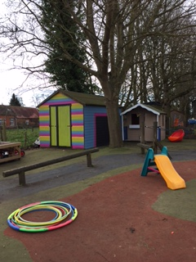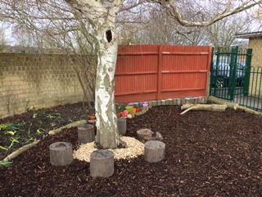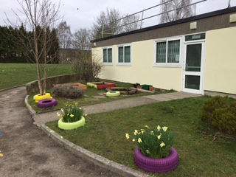
Thank you to Mr Burbank who arranged for Mike Whillock to come into a school assembly and for arranging free tickets for families to visit the Oxford Ice Rink to watch the Oxford City Stars win the league at the end of season ice-hockey match.
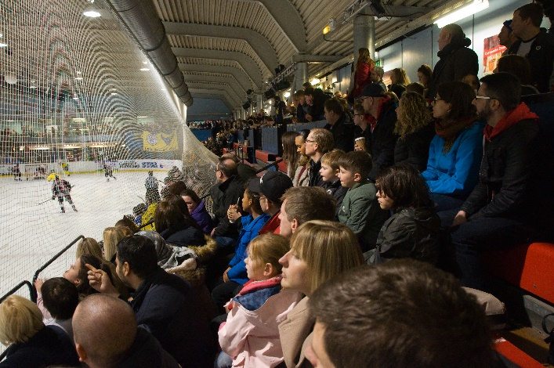

Thursday 29th March – End of term for Easter holidays at 12.10pm
Keeping your child safe on the Internet – essential information
Wednesday 25th April 2-3pm in the school hall. This will be led by Hertfordshire’s Esafety consultant – Richard Maskrey.

Have a wonderful Easter.
Many thanks,
Mrs. Burbank

PAs this week were Joseph and Matthew. Thank you for your help.

Last Friday we also enjoyed taking part in lots of sporting activities for sports relief. We started with a whole school daily mile. At lunch time, the teachers played the netball squad.....and lost 5-4!! In the afternoon, all the children took part in an obstacle course. Well done to the green house who had the quickest time over all and thank you to all the head leaders for helping to run the event!
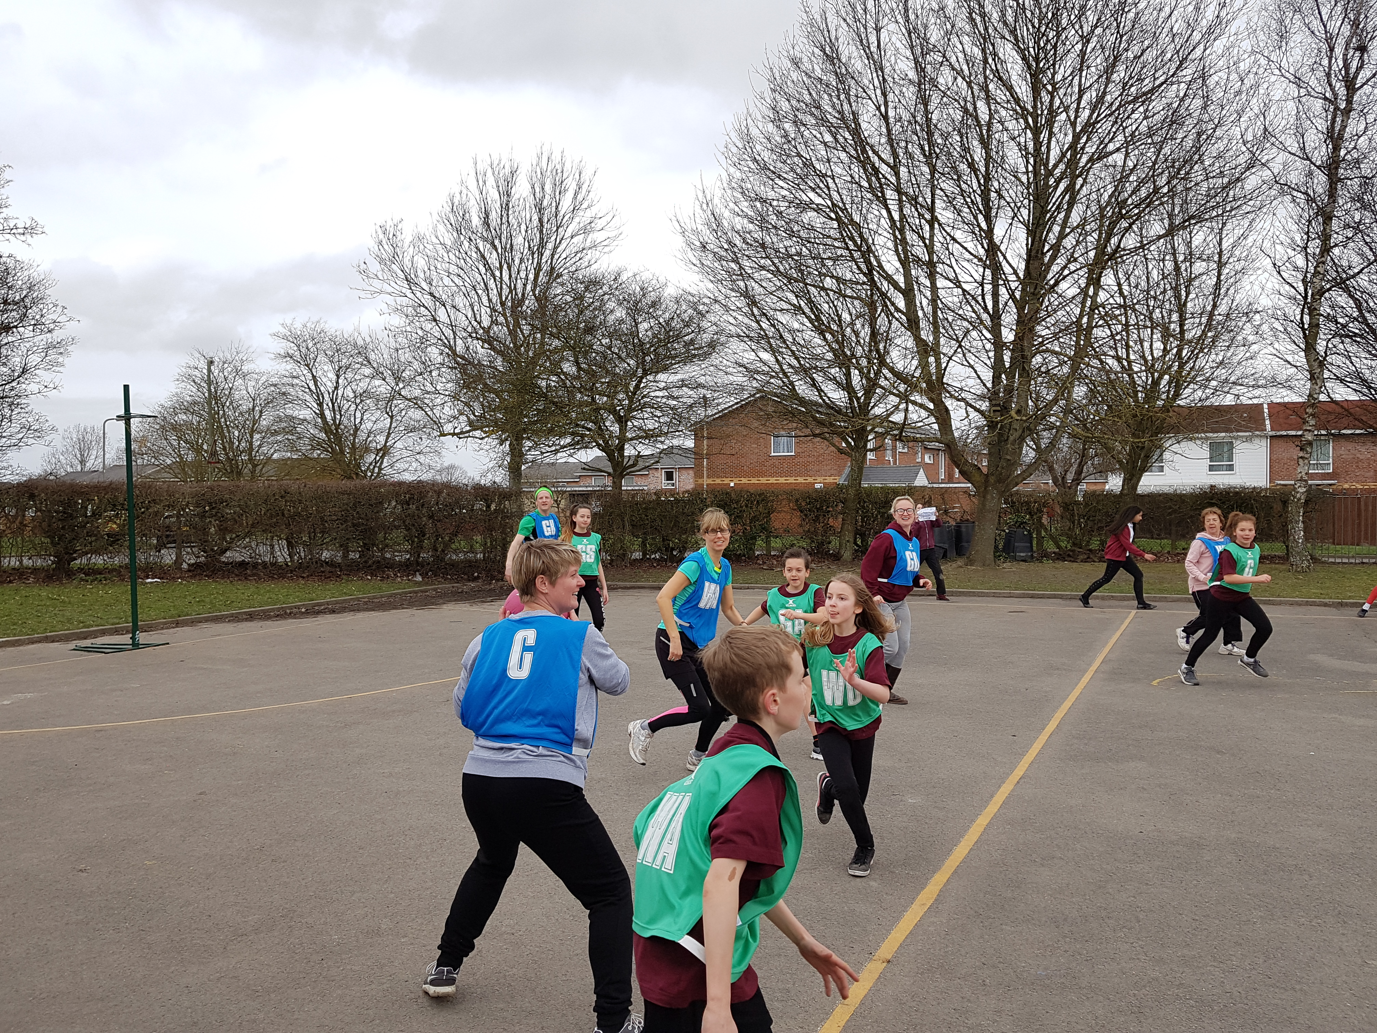

Mr. Burbank and Flo Stoermer are running the Race to the Stones on the 14th July. It is a 100km run following the Ridgeway. They will be raising money for new school laptops for the children. If you would like to make a donation would you please visit the link.
https://www.totalgiving.co.uk/mypage/sssh

Young Art Oxford art competition

Last term lots of children from Stockham took place in the Young Art Oxford art competition in aid of Cancer Research UK. The theme of the competition was ‘Journeys’ and we submitted lots of fantastic entries! We raised just over £256 for the charity. Thank you very much for all your donations.

Twenty children from our school have been selected to have their work displayed in a special exhibition at the Ashmolean Museum in Oxford.
These children are:

Charlotte – FS
Abigail – FS
Ava – FS
Isabelle – FS
Mia – Year 1

Tegan – Year 1
Lily – Year 2
Charlie – Year 2
Molly P – Year 2
Alfie Be – Year 3
Amber – Year 3
Charlie – Year 3
Lila – Year 4
Charlotte – Year 4
Kyla – Year 5
Ava – Year 5
Santi – Year 5
Jake – Year 6
Ollee – Year 6
Matthew – Year 6

The exhibition is open:
Thursday 10th May: 2pm-5pm (opening night 5.30pm-7.30pm – exhibitors and their families only)
Friday 11th May: 10am-5pm
Saturday 12th May: 10am-5pm

All unselected pictures will be ready for collection on 15th May from 25 Polstead Road, Oxford between 8am-6pm.

CLASS NEWS

Year F This week we have had lots of Easter fun. We have read the Easter Story and learnt
all about why some people celebrate Easter. In maths the children have enjoyed
decorating eggs using 2D shapes and making patterns. In literacy we have been
learning about questions, the children have worked in pairs to read the questions
and come up with their answers.
Year 1 In Year 1 we have written our traditional tales with Big Bad Wolves in them! We
have also added our decorated pebbles to our new garden area. We are very proud
of this new addition to our playground and would like to thank all those who helped
us on last Friday's Environment Day.
Year 2 We have been rotating shapes in maths this week. We have worked hard on using
the correct directional language in our lessons on this. We have really enjoyed
making magical garden models in D&T. All the parts move in different ways.
Year 3 This week in Year 3 we have spent some time outside writing poems about
Wantage, our writing was fantastic! In history we have learnt about the importance
of Wantage Market.
Year 4 This week Year 4 enjoyed erupting their fantastic volcanoes they made for
homework. They were all amazing! In maths we have begun learning about
decimal numbers and in English we completed a 'hot write' based on our play script
work.
Year 5 This week we have been working hard looking at fractions in maths and we
have started writing our Anglo Saxon myths! Some of us have also started cycling
proficiency!
Year 6 This week Year 6 have been writing their poetry – pop in and see our fantastic
display. In maths we have been solving fraction word problems.

Soaring High
This week the following children have earned “Soaring High”:
Year F Charlotte for her amazing writing. She has written some lovely stories and always
remembers her finger spaces and capital letters.
Year 1 All of Year 1 for another fun-filled and hard-working term!
Year 2 All of Year 2 for another wonderful term. You have all worked so hard, well done!
Year 3 Preston for brilliant confidence in guided reading. Hallie for amazing
independence and confidence in maths. Well done!
Year 4 Will for showing much more confidence in all subjects. Isabelle for always being
helpful and kind.
Year 5 All of Year 5 for a fantastic term. All of the children have soared high, using their
learning powers to overcome challenges during the term. Well done!
Year 6 All of Year 6 for a fantastic term, you have impressed me everyday.

Well done everyone!

Tidy Tiger
This week Tidy Tiger goes to Year 5 for having the tidiest room. Well done!

Attendance Ted
Attendance Ted was awarded to Year 4 for having the best attendance last week, they will be looking after Attendance Ted next week. Well done Year 4!

School Uniform
If you need new uniform please order online or by telephone. The website is pmgschoolwear.co.uk and the order line is 0800 4046644.
Book bags and PE bags are also available to be purchased from pmgschoolwear.

